# Central Michigan University Bicycle Rental System

### Ashley Boynton, Samantha Hough, Amy Sutter

## Abstract

Getting to class promptly and quickly is an issue many students struggle with. Especially when a student has two classes 10 minutes apart, but on different ends of the campus. There is a solution to this struggle: bikes. If a campus offered bikes for students to rent and use during their day to get to classes, people could get there quicker. We are suggesting a campus wide bike rental system available to all students and faculty. There would be multiple locations across campus for students and faculty to pick-up the bikes they have reserved through the system. This system would be a mobile-friendly web application. This way students and faculty can reserve their bike from anywhere, with ease and without worry.

## 1 Introduction

Students and faculty on campuses across the nation face several problems in their day-to-day life. One of the big problems for everyone is not having time. Maybe there’s not enough time to do all the homework as well as it could be done. Maybe there’s not enough time to catch up with a friend or coworker bumped into in the hallway between classes and get a long enough lunch break to fill up for the next several hours. Maybe the campus is so large that there is hardly enough time to make it from one class to the next on time without breaking into a jog. Bikes would make this trip easier and less taxing physically and mentally, but not everyone has a bike available to them or can afford to buy one. Not only would bikes get individuals from one place to another quickly, it is also an environmentally-friendly alternative to cars or buses. For these reasons and more, other campuses around the nation have been implementing bike rental (or bike sharing) programs that their students and faculty can take advantage of to make their day a bit easier. A program similar to others would benefit the physical and mental health of those on campus.

## 2 Background and Related Work

### 2.1 Campus Bicycle Shop Offering Sales, Rentals, and Repairs

While we did have some ideas on how we would create this application, we focused on doing research before we made any plans. We wanted to know how other campus have approached and handled the same problem. At Michigan State University in Lansing, Michigan, a program called MSU Bikes [1] was created to not only provide biking accessibility, support, and education, but encourages bicycling itself and being more environmentally friendly. They offer both new and used bikes that can either be purchased or rented from one of the halls on campus, as well as bike repairs and accessories.

### 2.2 Bicycle-Friendly Community

In Boulder, Colorado, students who are considering attending the University of Colorado are told that bringing a car isn’t even necessary. The city is a Bicycle Friendly Community as designated by the League of American Bicyclists. Even in the winter months, bike paths here are kept clear and useable for the community to use. On any given day, anywhere between 7,000 and 8,000 bikes are cruising around the campus, which could be expected since 75% of the students, faculty, and staff bus, bike, walk, or use a combination of the three to get to campus every day as explained in [2]. If an individual doesn’t have a bike of their own, for $30 a semester (and a $100 refundable deposit) they can rent a bike from the university and take advantage of the bike friendly community.

### 2.3 Integrated Technology

The University of California-Irvine has one of the first high-tech bike systems found on university campuses. Their program, called ZotWheels, allows students and staff to rent bikes for $40 a year. ZotWheets also requires each individual who wants to take advantage of the program pass an online safety course, and once they complete that, they will have access to a fleet of bicycles on campus that they can check out at will [3]. Each member receives a ZotWheels card that they can use at any of the four stations on campus. When the card is read, a bike containing an RFID tag is released from the docking station for them to use for the three hours. The RFID tag in the bike allows the system to track whether the bike has been returned to a station. If the three-hour deadline passes, the user’s card is automatically deactivated and fees can occur if the bike is not returned or is returned damaged.

## 3 Methodology

### 3.1 Existing Systems

While many schools above promoted the use of bikes and offered bikes for sale or rent to students, few had online rental forms. Schools like Michigan State University’s MSU Bikes program [4] offers bikes to rent for variable lengths of time, but students must call or visit a rental office to express intent to rent a bike.

Students at schools with systems such as the one described above needed to a rental facility or call ahead to find out if any bikes were available. This would be a problem for students in need of a quick response. Walking to a rental location could waste a student’s time if she gets there only to find out there are no bikes available for her to rent. Likewise, phoning ahead can be very difficult, at times, with crowd noise on campus as students move from one class to the next.

The schools that did have online rental forms did not use a responsive interface or mobile-friendly version of the web form. Sanford University does have an online form to reserve a bike [5] and had a mobile version of the web form. However, the form is not very user-friendly with its non-standard input areas.

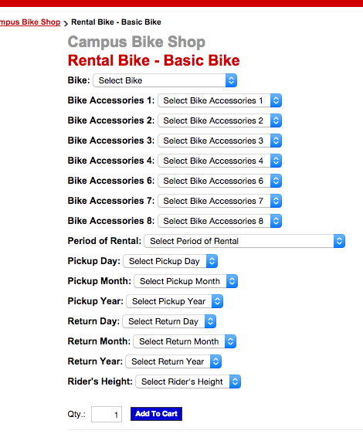

Figure : Sanford University Bike Rental Form - Desktop Version

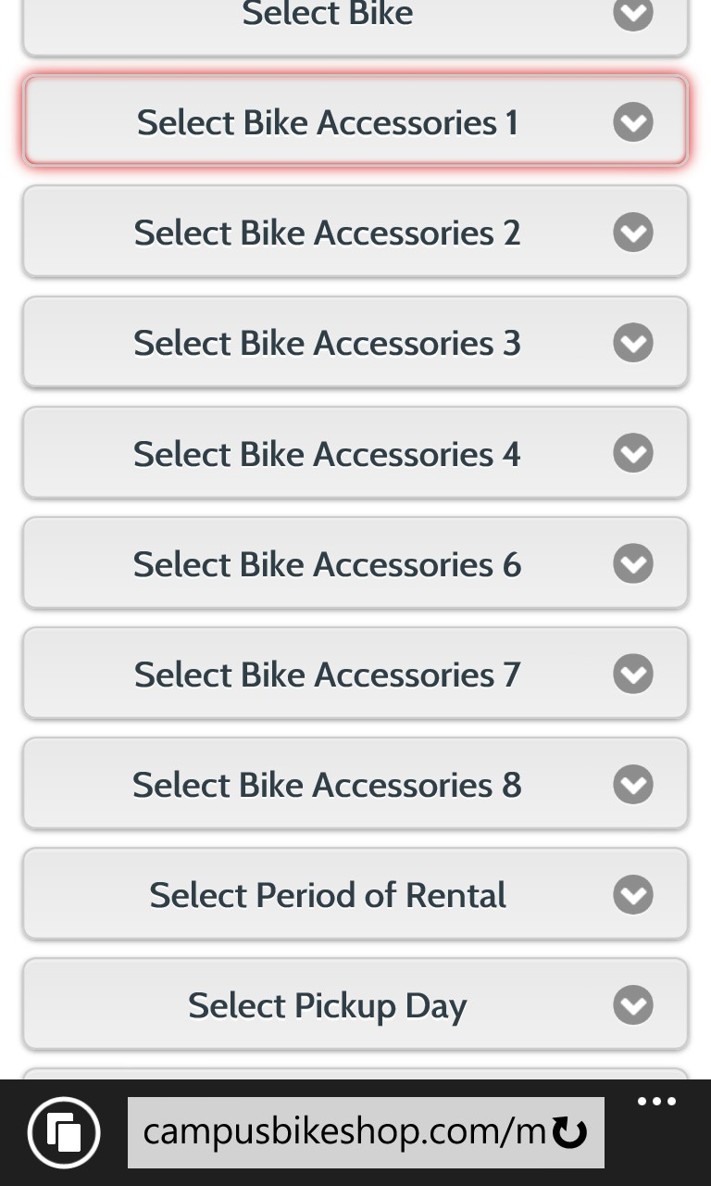

Figure : Sanford University Bike Rental System - Mobile Version

As shown in Figure 2, the input areas of the mobile site are not as intuitive as the standard white input areas like those showing in Figure 1. This can make the form confusing and difficult for some students.

### 3.2 Our Intended Outcomes

#### 3.2.1 Adding Convenience

Our intention was to create a more student-friendly system that would allow students to reserve a bike ahead of when they actually need it. This would allow employees to move bikes to the correct location as needed so students who reserved bikes would be certain that a bike would be available for her at the scheduled time.

### In addition to the ability to reserve a bike, we also wanted students to have easy access to the bike rental system from any location. We decided the best way to make the system available to use on mobile phones and tablets, in addition to traditional personal computers, was the use of a responsive interface for the web application.

#### 3.2.2 Building the Web Application

One of the first things our team considered for this application was how we were going to store any and all relevant data. This was not revolutionary by any means, but was a necessary step in creating a functional web application. Microsoft SQL Server is a great program that allows easy and clean database management and storage, so we decided to use it. Three tables were needed: one to hold information on the users, one for the bicycles, and one for check-out history.

We could use stored procedures within SQL Server to access and update the information in the databases, but Entity Framework provides an easy to use alternative. Entity Framework is “an object-relational mapper that enables .NET developers to work with relational data using domain-specific objects. It eliminates the need for most of the data-access code that developers usually need to write,” as described in [6]. Essentially, Entity Framework helps bridge the gap between code and database and makes it very easy to work with the objects in the database. When paired with ASP .NET MVC, data manipulation within an application is very easy to handle and clean.

MVC stands for Model-View-Controller, and is named so because of its use of the three types of programming entities. When Entity Framework and MVC are used together, the models used in MVC are automatically generated and updated by Entity Framework. The controller acts as a translator between the model and the view.

The view is what the user sees – in this case the view would be one of the pages on our application. The user can interact with the view and give it input, which the view can send back to the controller to determine its next action. For example, when a user wants to check out a bike, the view would communicate this to the controller, which can retrieve the available bikes. The controller would send the bikes back to the view so it can show the user the available bikes. Once the user makes a selection, the view tells the controller which bike was selected and the controller can use Entity Framework to update the necessary tables in the database.

The primary language used in writing the web application was C#. The Bootstrap HTML, CSS, and JS framework was used to aid in the implementation of the web application’s responsive interface. Bootstrap is a J-Query plugin that, by using different classes on different HTML objects, gives developers control over how the application will respond and reformat depending on the resolution of the screen. This made the application mobile-friendly and accessible from almost any device with a web browser.

#### 3.2.3 Implementing a Responsive Web Interface to Improve Usability Across Devices

The Bootstrap framework [7] was used to aid in developing a responsive interface that allows the web application to be easily accessible from both full-size computers and from mobile devices. Essentially, this means that our web application is aware of the size of the screen it is being displayed on and will use the appropriate code based on that knowledge to optimize the appearance and usability of the application. The simplified algorithm is shown below.

if screenWidth <= 768px

make input boxes extra-small

stack all elements vertically

collapse menu

if screenWidth > 768px

make input boxes small

stack most elements vertically

collapse menu

if screenWidth > 992px

make input boxes larger

display elements in normal desktop/laptop positions

expand menu

On smaller screens, such as those found on smartphones and tablets, the elements on the page will be stacked vertically to keep text legible rather than shrinking the whole page to fit the smaller screen. The action eliminates the need to zoom in to view the application pages on small screens.

### 3.3 Comparison

#### 3.3.1 Building the Foundation

Our application uses existing systems as the core idea. The common features of existing systems we studied were the ability to visit a rental station and get a bike and then later return the bike to that, or another, rental station on campus.

Some had a web form to reserve a bike ahead of the desired pick-up time, but many did not offer this feature. Of the systems we were able to view, none had a responsive interface. This means that none of the other systems were accessible from mobile devices.

#### 3.3.2 Improving Accessibility and Usability

We wanted to make the system available from both full-size computers and mobile devices. There were a few options to accomplish this goal. We could have used a web application with a standard interface and build a separate mobile app. This would have created problems with development and maintainability [9] since we would need to create and manage the web application along with a separate mobile interface for Android and iOS. Another option would have been to create a web application with a standard interface and a separate mobile site. This would have fewer problems with development maintainability, but would still require us to create and manage two designs.

The final option was a single site with a responsive interface. The responsive design allowed our web application to work on almost any device with an Internet connection and a web browser.

## 4 Analysis of Results

### 4.1 Physical Results

### *4.1.1 Mobile Application*

Our final result is a C# web application built in a responsive framework to be accessible from all types and sizes of devices. Today, this is becoming a practice that is more heavily being followed. According to a research study, half of the US and 62% of UK mobile phones are now smartphones [8]. That is a substantial amount of users—meaning that a good amount of users that will be using the application will be doing it from some type of mobile device as they are walking around campus. The bike rental program cannot and will not be successful if it requires users to only utilize the program from a desktop computer, hence a responsive web application.

### *4.1.2 Page Load*

Because the responsiveness of the application all happens on the client-side, each device—phone or tablet—receives the full amount of code and the browser uses what it needs [8] and large devices receive the same amount of code as the smaller devices. This could cause loading time issues in any responsive web application. If the application takes too long to load, the connection could time out. Now, what we needed to do was optimize our code and minify everything possible. All script, styling, and image files were minified in our building of the application.

It was time to test the optimization of our application. First, we needed to gather as many devices as we could. Then we would carry them to various locations with different Internet connections—strong or spotty [9]. What we should find is (regardless of the internet connections) the site takes no more time to load on a smartphone as it did on a desktop computer.

### *4.1.3 No Inline Labels*

The purpose of a responsive web application is user experience. The web application responds to the size of the device it is being loaded on by forming to fit the width of that device. In order to follow along with great user experience, we chose to use not use inline labels on our form (the label inside the form field). If an application uses inline labels, after the user fills in the form field, the label is lost. Then each form field looks just like the one before it [10]. Our final decision was to no use inline labels and to place the label above the field.

By placing the field under the label, the field can become the full width of the screen, making them large enough to display the user’s input in its entirety [11] as well as having clear and meaningful labels. Although, placing labels above the field takes up more vertical space and causes more scrolling. Ultimately, we believe that this is the best fit for a responsive web application.

### 4.2 Additional Considerations and Future Improvements

With limited time and no funding, we were unable to make use of some more advanced technology that would further improve and differentiate our system. While we hope that in the future our approach could be built upon to make it more efficient or high-tech, more time and funding would need to be dedicated to the project to make further improvements possible. We would also need the support of our university to be able to integrate the rental system with campus accounts.

With university support and account integration, students, faculty, and staff would be able to use our application and rent bikes with any Internet-capable device and charge the rental to their existing campus account. Once a user is logged in, the user would be able to view how many bikes were available at the locations near her and reserve one for use in the near future. Each bike would be equipped with an identifier that the user would input into the application so they would be able to complete the check-out process. When the user is done with the bike, she would log back into the application, check the bike in, and be on their way. From this application, users would also be able to report issues about bikes and make rental payments.

Another technology we would like to use if we could find funding is global positioning. Using GPS to track bikes would aid in recovery of lost, stolen, or abandoned rentals. This could potentially result in a cost savings for the rental system over time. It would also allow us to show students the location of their rental bikes on a map so they could easily find it again if they forgot where they parked.

## 5 Conclusion

This application is a tool that was intentionally left with room to grow. We have taken several other approaches to the issue of quick, easy transportation on campus, and created Central Michigan University’s first step of solving this issue. Unlike other similar applications, we have a clean, responsive interface that works wonderfully on a range of devices. Unfortunately, we did not have the resources necessary to add some other features to this application that others have, such as GPS trackers on bikes, automated bike stations, membership cards, etc. However, what we do have is a user-friendly, mobile-friendly, and efficient way for students to save time and sanity by being able to rent faster transportation on the go.

# References

[1] “Green transportation,” <http://ipf.msu.edu/green/practices/green-transportation.html>, 2014.

[2] M. Ezarik, "Biking: by the numbers," *University Business: 14.3*, pp.16, <http://go.galegroup.com/ps/i.do?id=GALE%7CA252087047&v=2.1&u=lom_cmichu&it=r&p=AONE&sw=w&asid=8f4c1afb69908174e4fc71e5e7b3e29d>, Mar. 2011.

[3] M. Kennedy, "PROMOTING PEDALING," *American School & University 82.9*, <http://go.galegroup.com/ps/i.do?id=GALE%7CA224851903&v=2.1&u=lom_cmichu&it=r&p=AONE&sw=w&asid=1cd44db0f1cbe428678b294f988951ae>, Apr. 2010.

[4] “MSU Bikes,” <http://bikes.msu.edu/?page_id=62>, 2014.

[5] “Campus Bike Shop on the Sanford University Campus,” <http://campusbikeshop.com/product/campus-bike-shop-rental-bike-basic-bike-1138.htm>, 2014.

[6] “Entity Framework,” <http://msdn.microsoft.com/en-us/data/ef.aspx>, 2014.

[7] *Bootstrap*, <http://getbootstrap.com/getting-started/>, 2014.

[8] “Usability on the Mobile Web: Best Practices and Guidelines for Designers and Developers,” MobiForge, <http://mobiforge.com/design-development/usability-mobile-web-best-practices-and-guidelines-designers-and-developers>, Apr. 2013.

[9] A. Schade, “Responsive Web Design (RWD) and User Experience,” Nielsen Norman Group, <http://www.nngroup.com/articles/responsive-web-design-definition/>, May 2014.

[10] J. Appleseed, “Mobile Form Usability: Never Use Inline Labels,” Baymard Institute, <http://baymard.com/blog/mobile-forms-avoid-inline-labels>, Jun. 2013.

[11] C. Holst, “Mobile Form Usability: Place Labels Above the Field,” Baymard Institute, <http://baymard.com/blog/mobile-form-usability-label-position>, Mar. 2013.

*This hasn’t been used yet anywhere in the paper*

[12] “Principles of Mobile Site Design: Delight Users and Drive Conversations,” Google and AnswerLab, pp. 25-30, 2014.